A set of 20 monetised ‘Customer Journey Maps’ commissioned to illustrate the social & economic impact realised by Housing First in the Liverpool City Region

Commissioner of this synthesis | Amanda Bloxsome – Best Practice and Partnerships Lead
Methodology | - Single case evaluations of the situations, circumstances, and behaviours of each of 20 service users chosen by first-line practitioners and managers of the Housing First pilot were used to create Customer Journey Maps to make sense of any difference produced by this way of working  - Relevant recognised sources were then used to attribute a financial value to stakeholders in a management of demand inherent in any change produced by Housing First in these service users’ situations, circumstances and behaviours
Stakeholders | - People in the Liverpool City Region who are homeless, in tenuous accommodation and/or who are at significant risk of becoming homeless.  - The 6 Local Authorities of the City Region.  - The span of Public and Third Sector Services with an operational remit/ footprint in the City Region; and, which – directly or indirectly - provide services with people in the Region who are homeless.  - H.M. Government, which has provided funding for the Housing First programme in the City Region as one of the three national pilots.
Summary | This group of Customer Journey Maps illustrates ways in which Housing First supports service users often challenging pathways out of homelessness - grounded in the choices, intensity, and flexibility – offering practical, grounded examples of the difference made by this way or working with people who are homeless. The changes produced in the situations, circumstances and behaviours of this group of service users has both economic and social value:  - A management of demand on public services brings a value of £880,433.  - The quality of life and well-being across and amongst the group of service uses equates to around £281,242 p.a. (after recognised moderators have been applied to take account of the early stage in their ‘social careers’).  This set of monetised Customer Journey Maps offers evidence of Housing First as a cost-effective, solution-oriented approach in switching-off failure demand inherent in crises in the situations, circumstances and behaviours of people who are homeless that exceed the capacities, threshold criteria and processes of ‘As Is fragmented responses across Local Authorities and public services.
Implications and learning | Against a dynamic, turbulent and difficult context that includes Covid-19, exponential increases in demand (need for services) and significant pressures on the budgets of Councils and public services in the City Region sustainable funding – beyond the pilot period - should begin to be agreed to underpin an insight informed ‘equilibrium shift’ being realised by Housing First with people who are homeless as an integral element within service delivery arrangements for people who are homeless in the Liverpool City Region.
Author | David Hoyle PhD, D.Litt., MSc, M.A. (C.I.Psychol (rtd)) M.A. (Dip SW).  Chief Impact Architect, beyondbetter.
Version number | Draft V0.2
Date | May 2022

What?

Contexts

It can be comfortable and convenient for politicians, resource holders, decision makers and the media to perceive ‘The Homeless’ as personally accountable for the situations and circumstances in which they find themselves. In the real-world homelessness is an outcome of complex interactions, inter-relationships and interdependencies between events and episodes in a person’s personal history and their situations, circumstances, and behaviours. Such deep and often long-term, multiple complexities in people’s personal histories must then be set against landscapes of local spaces, places, and service delivery arrangements – amongst others, different local authority areas, primary and acute health Trusts (including mental health and substance misuse services), clinical commissioning arrangements, community and voluntary sector agencies, social housing providers and criminal justice agencies.

Since 2010, strategic and operational decisions across and amongst public services have led to an emergence of greater space between the statutory responsibilities, rational threshold criteria and operational processes as organisations have re-trenched to attenuated ‘Core’ ( C ) activities and statutory functions to manage operational boundaries and scare resources – whilst such scarcity of resources has led to discretionary services (the paler/outer ring in the graphic, below) being progressively eroded out of existence or robustly de-prioritised. In this context, the challenging situations, circumstances and behaviours of ‘The Homeless’ lose visibility in cross operational spaces, access criteria and resource driven strategic boundaries,
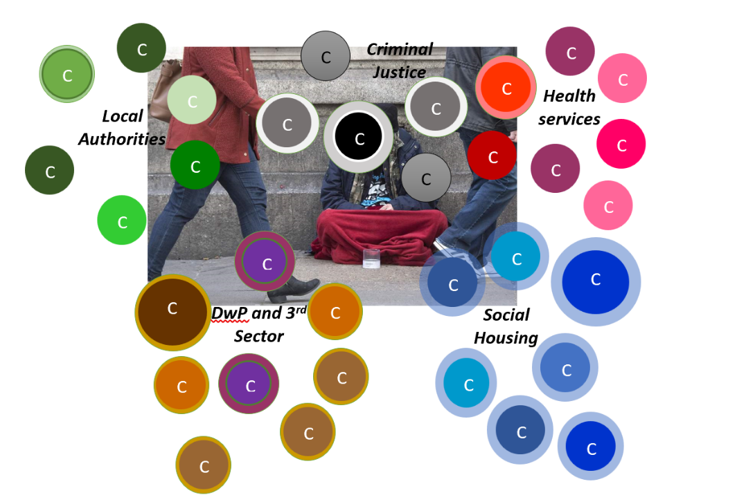

In several countries, Housing First is being adopted as an evidence informed, integrated, systemic way of working with people whose homelessness is associated with multiple, long-term, complex situations, circumstances, and behaviours. Research in the USA, Australia, New Zealand, Finland, Denmark, and France provides good quality, triangulated evidence of a very real potential in authentic, high-fidelity Housing First delivery models to produce outcomes that are cost-effective. In the UK – despite such evidence – there remains a deep scepticism at national and local levels amongst stakeholder organisations around the claims made about the value in ‘Housing First’ as a cost-effective solution with an integral role in a repertoire of local, sub-regional, regional, and national responses to institutionalised homelessness.

- In England’s contemporary economic and social contexts, resource holders, decision makers and commissioners may choose to perceive homelessness as ‘Someone Else’s Problem’ - that is a ‘Problem’ for an agency/organisation other than them - rather than an outcome of complex situations and circumstances that necessitate a co-ordinated, multi-dimensional approach that starts from a stable home.

- Attenuated (low fidelity) delivery models put in place by some early Housing First ‘wannabees’ – contrary to established evidence-based principles (Appendix A) - has created a potential to erode credibility in the effectiveness of this way of working.

Objectives of this study

The scope and intention in this study are set out in Appendix B

Methodology

A full and detailed description of the ‘Client Career Heuristic’ – Customer Journey Mapping – used in making sense of the ‘social careers’ of the group of 20 service users chosen by first-line practitioners and their managers is provided in Appendix C.

Some examples from the set of 20 Customer Journey Maps

The 20 service users chosen by first-line practitioners and their managers for this study on behalf of the Housing First pilot were allocated anonymised names/identifiers. These were: John, Jane, Nikki, Jess, Brian, Joe, Katie, Laurence, Jack, Harry, Mark, Andrew, Betty, Jimmy, Peter, Cheryl, Jim, Sean, Michael and Lucy.

So what?

Inherent in Customer Journey Mapping is a systemic mind-set or worldview. This suggests a useful metaphor in presenting findings from the study - the set of 20 monetised Customer Journey Maps – is that of an iceberg:

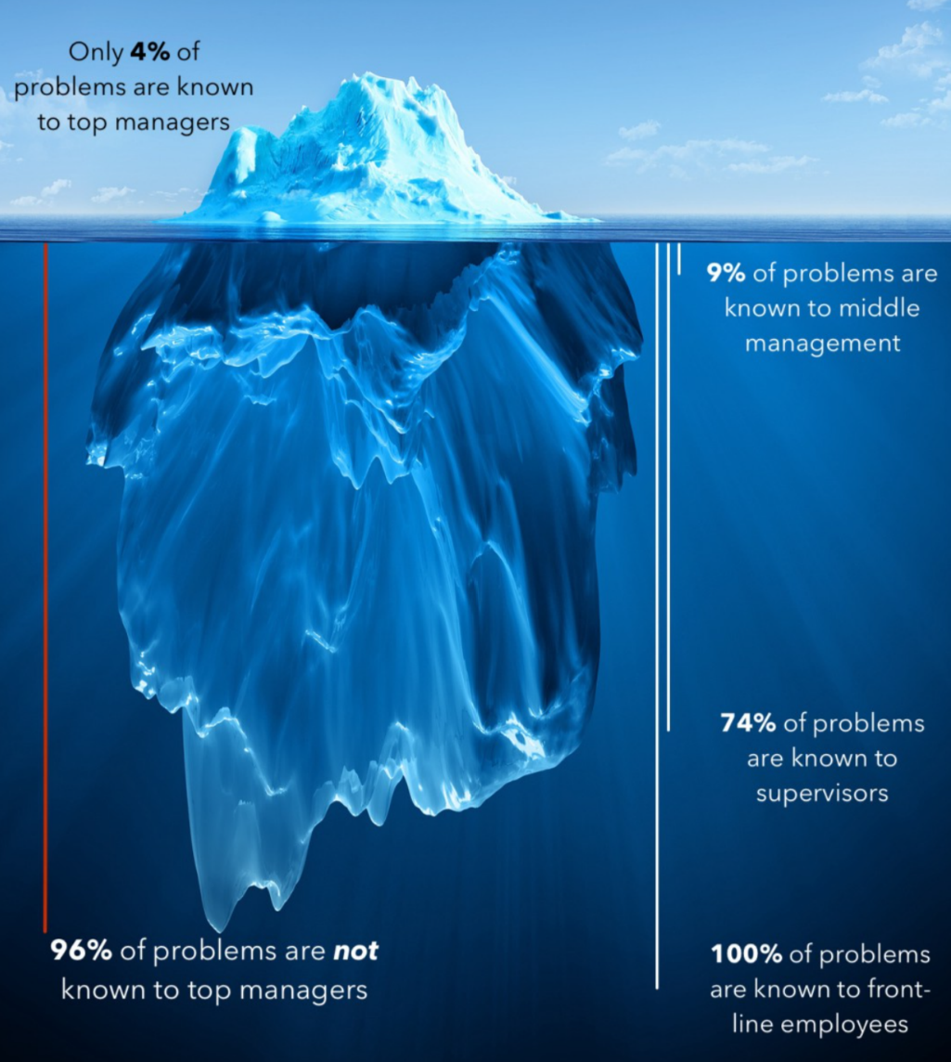

- A visible surface – ‘The Numbers’ – for example, how many men and women in the set of 20; a list of challenges faced by service users in the study sample; the agencies involved with this sample of service users; and a monetisation of any change produced by Housing First with this sample of service users.

- The limen between visibility and invisibility – patterns across the set of Maps that offer insights and emergent evidence of the products/outcomes of the flows of resources, information and rules of As Is (please see end-note 1 later in this briefing for an explanation of this concept/ phrase) service delivery arrangements as expressions of a complex system.

- The invisible depths – events, episodes and patterns from the set of Maps which offer clues about the distribution of power over the rules governing the system, the goals of the system and, the mindset or mental models out of which the As Is system arises (please see end-note 2 later in this briefing for an explanation of ‘invisible depths’ in fields of practice).

- The secret in producing positive change with people whose lived experiences have produced their homelessness and the situations, circumstances and behaviours which are germane to their homelessness.

Individually and collectively the 20 monetised Customer Journey Maps both illustrate and provide evidence of the change achieved by these service users within support:challenge interactions with their Support Worker. The high-fidelity delivery model implemented by the Housing First service in the Liverpool City Region has established a culture, belief system and aspiration within which Support Workers can be the best that they can be in the relationships and conversations which are effectors of change with people who have personal histories characterised by multiple, long-term and severe complex trauma.

(graphic © Gaping Void Culture Design Group; used with permission and under licence)

It is extremely rare for people with histories of complex trauma to change because they are told to do so, because some arbitrary threshold is imposed upon them or in compliance with some legislation – distanciated and meaningless from the realities of their everyday experience. Change – such as that evidenced in the 20 Customer Journey Maps - is a product of a relationship and conversations with someone in whom they feel comfortable and confident to gift a level of trust.

Whilst principles and structures provide a framework, it is the culture and mind-sets established within and by Housing First – and the beliefs and aspirations immanent in that way of thinking about homelessness – that create a vehicle for equilibrium shift in services for people who are homeless:

- Partnership strategy and structures don’t.
- Service processes and systems don’t.
- Thresholds and access criteria certainly don’t.

Being told or instructed (nagged) doesn’t produce change. If someone feels that another person is taking a genuine and authentic interest in their safety and well-being, they are more likely to invest trust. The change is a product of an emotion and feeling – that as a person who is homeless, I feel

that someone is interested in me and is willing to walk alongside me in coming to terms with and beginning to address the complex trauma in my personal history. Examples from the 20 Customer Journey Maps that strongly illustrate the significant change which can be produced with service users by support workers within the Housing First culture and mind-set include: Jimmy, Jess and Peter.

2. Findings: the visible surface

1. The group of 20 was made up of 13 men and 7 women.

- A gender imbalance in the group mirrors an imbalance in both the caseload of the Housing First pilot in the City Region and in the population of the ‘visible’ homeless across England.

- Other studies (e.g., Hoyle/THP, 2016) have identified ‘invisible’ homelessness amongst women as a particular challenge for public services. The numbers of women in the City Region living lives of exclusion, violence, invisible homelessness and quiet desperation beyond the visibility of As Is service delivery arrangements is beyond knowing.

2. The numbers of service users from the study sample were drawn from the 6 local authority areas of the City Region.

3. A New Directions Team Assessment – NDTA - ( http://www.meam.org.uk/wp-content/uploads/2010/05/NDT-Assessment-process-summary-April-2008.pdf )was undertaken with 10 of the service users by their Support Worker. at, or close as possible to the point of their transition to becoming a user of the Housing First pilot

- The NDTA – often also known as the ‘Chaos Index’ - was developed by the New Directions Team in the London Borough of Merton to more effectively identify individuals or groups who are not engaging with frontline services, with the outcome of their multiple exclusion, chaotic lifestyles and negative social outcomes for themselves, families and communities.

- The Assessment is based on 10 areas of a person’s situation, circumstances and behaviours. The maximum score is 48, which is an indication of an extremely high level of ‘chaos’ in a person’s life and personal history.

Outcomes of the assessments undertaken with the 10 service users were:

- The mean (average) score was 36.2
- The scores ranged from 28 to 44
- The median (mid-point of the range) was 35.5

Such outcomes from these assessments fall into the highest quintile of potential scores – which is indicative of a very high level of ‘chaos’ in the lives and personal histories of the 10 service users where an assessment was undertaken.

4. As illustrated by the ‘Chaos Index’ scores of half of the group (for various operational reasons, in the early stages of the pilot a ‘Chaos’ assessment wasn’t undertaken), the lives and personal histories of the 20 service users reflect multiple situations, circumstances and behaviours.

Amongst the group of 20 service users:

- Common themes in the lives of the group were drug misuse (16 (80%)), mental health challenges (15 (75%)), ‘Vulnerable Adults’ (12 (60%)) and patterns of offending (11 (55%)).

  - Despite the prevalence of such themes none of the service users presenting with mental challenges and drug/alcohol misuse had a formal ‘Dual Diagnosis’ (co-morbidity) or associated integrated care plan.

- Other significant themes in the lives of these service users were alcohol misuse (10 (50%)), disability (8 (40%)), learning disabilities (including cognitive impairment and specific learning disabilities (7 (35%)) and domestic abuse (6 (30%)).

  - Undiagnosed learning difficulties had major outcomes on the lives and lived experiences of several the group of service users. Often bringing challenges in their day-to-day living, their responses to stressors and challenges in their lives, their confidence and self-worth, and their capability and capacity to engage with services.

  - There was a gender imbalance in the service users who experienced domestic abuse – of the 7 women in the group of 20 service users, 5 experienced domestic abuse.

5. The ‘Private Troubles’ amongst the group of 20 service users - their personal histories, complex trauma, situations, circumstances and behaviours – have escalated far, far beyond a tipping point or threshold and become – or should have become (see subsequent sections of these findings) - a ‘Public Issue’ for public and voluntary sector services.

Amongst the group of 20 service users:

- Multiple, severe and long-term physical health problems meant 17 of the group were supported in their access to specialist health services; the behaviours of either the service user, their partner or associates meant 15 were in frequent contact with the Police; and 13 of the group were known (or had historic contacts with) community and voluntary sector services supporting people who are homeless and people with drugs and alcohol misuse challenges.

- Common contacts were with Department for Work and Pensions/JobCentre, the criminal justice system, mental health services, housing options and supported accommodation providers.

6. Homelessness represents a concrete example of ‘Failure Demand’, This is a term developed by John Seddon Founder of the Vanguard Method ( https://beyondcommandandcontrol.com/john-seddon-and-the-vanguard-method/ ) to describe demand (need for services on an organisation’s resources which is an outcome of a failure by another part of the organisation – or by other organisations - to do something or do something right for a person or a group of people. Where their needs are not met, people return to access points of organisations again and again, making further demands unnecessarily occupying or consuming an organisation’s resources.

- Homelessness can be understood as an outcome of a failure by public services over time to organise interventions in ways, in places and at times that facilitate professional relationships and conversations which in turn are effective catalysts for change with people
who have personal histories of complex trauma, abuse, offending behaviours and/or long-term, multiple, sever and complex mental health and learning challenges.

Choices, intensity and flexibility immanent in the delivery of Housing First by Support Workers produces change with service users which ‘switch-off’ this failure demand within service delivery systems across the City Region. This ‘switching-off’ failure demand that would bring a return of a person to their access points and operational services has a value to public services.

- For example, 5 of the service users in the group of 20 have histories of offending and custodial sentences – at a unit cost of around £39k per annum per episode. The relationships and conversations created by Housing First Support Workers with these service users enabled all 5 to remain offence-free for several months or throughout the whole period of their ‘social career’ in this study (total value – a hypothecated economy or ‘saving’ of £195k). So, an outcome of these interventions by Housing First is a switching-off of demand on the Prison Service and other elements of the Criminal Justice System (the Police, Courts and Offender Management Services).

The aggregated value to public services produced with the group of 20 service users by Housing First Support Workers was £880,433. Examples of the value produced with individuals were:

As is surfaced in the above chart, change produced with service users by Support Workers also has a value to the people themselves – positive change in their engagement and trust in services, feelings of greater control in their lives, improved feelings of self-esteem/self-worth. Although for almost all of the group, their enmeshment in the histories, circumstances and behaviours which led to their referral to the Housing First pilot meant that any positive change was at a very early stage. An econometric ‘Well-Being Valuation’ model developed at the London School of Economics (Centre for Economic Performance), provides a recognised approach in monetising the value to individuals in such emotional and social change in their situations, circumstances and behaviours.

3. Findings: the limen between visibility and invisibility

Patterns in the change in people’s lives surfaced by the Customer Journey Maps offer emergent evidence of the outcomes of the flows of resources, information and rules of the As Is complex system across and amongst public sector services and other organisations in the City Region.

- Contemporaneous case notes and Customer Journey Maps for several service users in the group of 20 illustrate ways in which the Police Service and Criminal Justice System in the City Region have become a default provider in the spaces and places between As Is service delivery arrangements.

  - In a written opinion to the Housing First programme about one service user, a qualified and experienced mental health practitioner suggests this service user ‘is one of the ten most chaotic women in the city.’ Yet in the minutes of a multi-disciplinary meeting about this same service user a Senior Manager from Adult Social Care is noted as having advised that ‘[Service User] should be offered a general tenancy, even if it fails and she is sent to prison.’

- Emergent evidence provided by case notes and Customer Journey Maps of this group of Housing First service users illustrates high levels of very low functional literacy and of unacknowledged and undiagnosed Learning Difficulties (including Specific Learning Difficulties – e.g., Autistic Spectrum Difficulties) and Cognitive Sequencing Difficulties.

  - For example, the Customer Journeys of the service users known as John, Laurence, Jack, Harry, Jimmy, Cheryl and Michael illustrate the impact of such ‘invisible’ challenges on the day-to-day lived experiences of these people – and on their self-esteem, self-worth, capacity, and capability to successfully sustain a tenancy or suitable accommodation.

- Whilst a challenge that is not unique to the City Region, case notes for the 20 service users surface examples of avoidable delay in the pathways out of homelessness which are directly attributable to the limited availability of some types of accommodation and/or the availability of suitable housing in some areas of the City Region. Succinctly, there is emergent evident from the single case evaluations of people’s homelessness being extended or perpetuated as an outcome of the limited supply and low requisite variety of housing and accommodation.

  - Harry Jack and Mark – for different reasons – each expressed a choice of particular area, which became problematic in making progress. Harry wanted a home somewhere close to his mother – with whom he was attempting to re-build a positive relationship. Jack wanted a property well away from his ‘home’ area – to distance himself from the situational reinforcement of drug misuse and offending amongst his former associates. Mark had been the subject of separate violent attacks whilst rough sleeping and wanted a home away from those areas to manage anxieties about a move ‘indoors.’

  - Cheryl had (and continues to have) a deep ‘fixation’ on her town and was adamant in her choice of a home there with her partner. However, the availability of accommodation suitable for a couple in that area was extremely poor.

4. Findings: invisible depths

At a deep level, events, episodes and patterns surfaced by single case evaluations that grounded the production of the Customer Journey Maps also provide insights into the distribution of power over the rules which underpin the organisation and delivery of services with people who are homeless in the City Region as a complex system, the goals of that system and, the mindset or worldview out of which the As Is system emerges.

- Case notes and Customer Journey Maps provide evidence of the ways in which a management of demand immanent in taken-for-granted and As Is service delivery arrangements can institutionalise an exclusion from services amongst people who remain enmeshed in lives of quiet desperation, violence, substance misuse, and multiple chronic, long-term and severe mental and physical health challenges.

  - Jess and Jimmy offer examples of how an outcome of experiences throughout their lives seemed to be that many of the 20 service users held a learned mistrust of public – and particularly statutory – services: in some cases, because of being ‘let-down’ by services in the past; in others where the person had been subject of frequent changes of worker; in others where services had told the service user one thing but then done something different; and in others where gifting their trust to a worker had led to negative outcomes for them.

  - Andrew, Laurence and Michael offer examples of the impact of a 19th century bureau-professional expectation that to access a service the client/patient must attend an appointment (often arranged weeks in advance) at a site (often some distance from where they are living) during conventional weekday working hours. Quite simply, As Is services for people whose homelessness and tentative/insecure accommodation is rooted in complex trauma and dependencies are not organised, delivered and evaluated in ways, in places and at times that are meaningful for them.

  - Laurence, Sean, Cheryl and Mark offer examples of a common theme in several of the case-studies was declining to provide a service because of failed appointment (the criterion often seemed to be that 2 failed appointment meant a referral or case would be closed by the agency) or a subjective judgment that a person’s situations, circumstances and behaviours weren’t sufficiently severe to be offered access to services.

- Whilst case records and Customer Journey Maps offer examples of outstanding passion, commitment and effort amongst first-line practitioners to make things work for their service users despite their organisation’s systems and processes; those case records also offer abundant examples of the ‘Failure Demand’ created by an organisation-centric, silo-driven and fragmented mind-set and worldview.

  - The case records and Customer Journey Maps of all 20 service users provide examples of how they – and their histories, situations, circumstances and behaviours – do not ‘fit’ the neat, rational ‘box’ circumscribed and maintained by the service delivery processes, threshold criteria and access points at the boundaries of an organisation (and departments/sections within organisation).

  - In practice, each organisation assumes a vertical perspective (downwards through the organisation/ department from the Chief Executive to first-line practitioners) on people whose situations, circumstances and behaviours are deemed to have made a transition from

a ‘Private Trouble’ into the realm of a ‘Public Issue.’ The atomised and sometimes contradictory landscape created by such fragmentation produces an avoidable complexity which people who are homeless are simply cannot navigate.

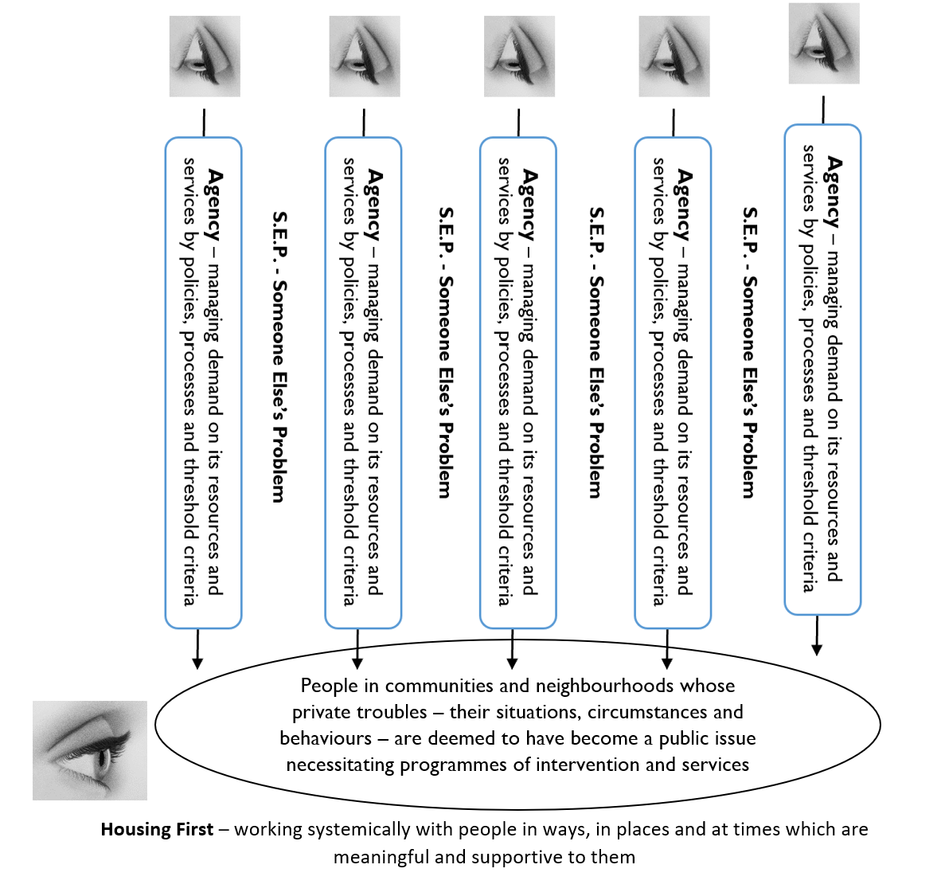

What next?

On the streets of cities and towns across the UK, in our communities and in our daily newsfeeds we are presented with both quantitative and qualitative evidence of a ‘Failure Demand’ inherent in ‘As Is’ strategic, operational and commissioning arrangements for services with people who are homeless (and people whose lived experiences of complex trauma, abuse and violence place them at greatly increased risk of becoming homeless).

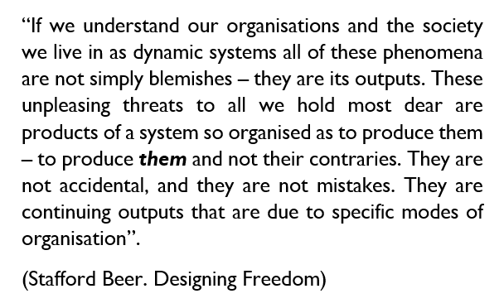
“We cannot solve the significant problems we face using the same order of thinking that was used when they were created”
(Attributed to Albert Einstein).

Or as an image by Banksy conveys:

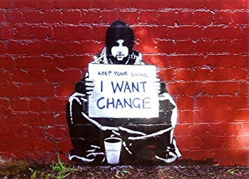

Resource holders, decision makers and commissioners in the City Region may wish to have regard to emergent themes surfaced by set of Customer Journey Maps – to effect change in the As Is through solution oriented – “We can … if” dialogue, insight-informed action and commissioning.

- A need for a shift in mind-set about people who are homeless from a rational Newtonian view to a complex systems perspective. Such a shift in how we think about a ‘Problem’ is one of the most effective leverage point in effecting systemic change in genuinely shared sense-making about Failure Demand (such as homelessness) generated within As Is service delivery arrangements. Dialogic change offers a basis to ‘switching-off’ demand through movement towards more integrated, place based inter-agency ‘pathways’ and ‘signposting’ which start from grounded insight about the situations, circumstances and behaviours from which homelessness emerges.

- Exploring, developing and implementing requisite variety in services and accommodation across the City Region as a complex adaptive system. Evidence of the impact realised by Housing First with people whose homeless is associated with some of the most chaotic situations, circumstances and behaviours in the City Region illustrates how and why services and support with people who are homeless need to embody requisite choice, flexibility and intensity.

  - To attenuate demand, a landscape of services and support should be offered - in ways, in places and at times - which are sensitive and relevant with people who are homeless (and people whose situations, circumstances and behaviours are associated with a high risk of becoming homeless); and are sensitive and responsive to the different situations, circumstances and behaviours associated with the homelessness of men and of women.

- A need to embrace and build forward from emerging evidence from the Housing First pilots -and much more widely - of ‘What Works.’ Making sense of how the Housing First delivery model realises both Value for Money and strong positive social impact whilst maintaining a healthy scepticism in exploring and identifying limitations in such evidence as part of pro-actively supporting people’s pathways out of homelessness in the City Region.

- It would be extremely naïve and foolish not to recognise the significant funding challenges facing Local Authorities and public services across the City Region. Even so, a need should be to secure a medium/ long-term sustainability for Housing First as a core element within the local system of service delivery approaches with people who are homeless or who are at risk of becoming homeless. Sustainability is important for two reasons.

  - So that awareness of how Housing First makes a difference with people whose quality of life is severely diminished by homelessness can become embedded in local communities across the City Region/Combined Authority and people at greatest risk of homelessness can rely on a service that is sensitive to their situation and circumstances being available; and,

  - More evidence can be generated about the longitudinal impact (outcomes) of this way of working with people who are homeless.

The ‘social careers’ of the 20 users of the Housing First service illustrates the impact realised by this way of working and the significant potential in it to deliver sustainable cost-effective solutions with people whose homelessness is grounded in personal histories of complex trauma and/or long-term, severe, multiple and complex situations and circumstances. Whist resource holders, decision makers and commissioners must have regard to their increasingly scarce resources, the potential in the Housing First delivery model to transform the quality of the lives of people existing in lives of despair, dependencies, violence and invisibility at – or beyond - the margins of contemporary civic society in England should not be overlooked.

The Housing First delivery model and pilot programme offer opportunities for sustainable socially significant equilibrium shift in the City Region. These opportunities appear to fit very well with the organization and delivery of regionally and nationally significant innovation in services with people who are homeless. This innovation is necessarily grounded in a systemic ‘We Can If’ mind-set; a capability and capacity to co-create contextually relevant ways of working; and an appetite and ambition for supporting and challenging positive change – making a difference – with people who are homeless (or at risk of homelessness) across the Liverpool City Region.

Endnotes

Endnote 1 – ‘As Is’

‘As Is’ is a phrase and concept commonly used in Business Process Re-engineering (BPR) Business process reengineering can also sometimes be known as business process redesign, business transformation, or business process change. https://en.wikipedia.org/wiki/Business_process_re-engineering.

‘As Is’ offers a shorthand for exiting (pre-change) hierarchical and functional structures, access thresholds and processes created by decision makers and resource holders in an organisation to carry out the ‘work’ and tasks of the organisation (or – in the case of systemic service delivery – organisations). The ‘As Is’ provides both a starting and reference point or baseline in future evaluations of the difference made by transformations in the processes and structures of a business or organisation – the difference realised by the change with and for customers, employees and the organisation.
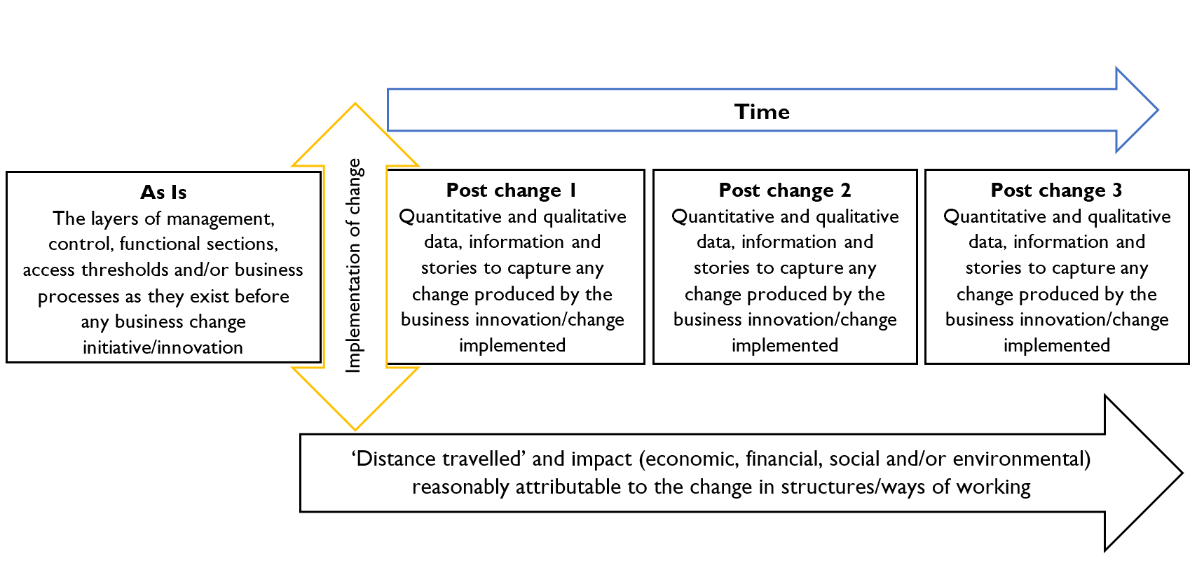
Endnote 2 – ‘Invisible depths’ in complex adaptive service delivery systems

The taken for granted beliefs and assumptions that inform how organisations and businesses organise themselves to carry out their ‘work’ and tasks can be traced to emergent 18th century industries and the Industrial Revolution – for example; Adam Smith’s example of a Pin Factory https://www.adamsmithworks.org/pin_factory.html and F.W. Taylor’s ‘Scientific Management’ http://www.netmba.com/mgmt/scientific/#:~:text=In%20another%20study%20of%20the,of%20the%20substance%20being%20shoveled.

Until the mid/late 1970s, these beliefs and assumptions provided comfortable and familiar models for the organisation of work in traditional industries. Since then, an increasing turbulence in business environments has meant these beliefs and assumptions are ever more unreliable – which has provided the catalyst for innovation in products, relationships with customers, operating structures and a breadth of ways of working, for example https://www.humanocracy.com

In the same way that such beliefs and assumptions have become increasingly unreliable in other sectors, they also fail to offer reliable, sufficient or appropriate cognitive models for the organisation of the work of the span of bureaucratic-professional public services that have been brought into being over the last 40 years. In addition, severe and continuing reductions in budgets and growing (sometimes adversarial) scrutiny from sector regulators, Inspection agencies and the media have significantly eroded any confidence, competence and willingness in public services to explore experiment and implement radical equilibrium shift in their structures and ways of working to produce effective in high variety, high demand, dynamic, resource scarce, data overloaded business environments. In the face of such pressures and tensions in their organisation and delivery of services for citizens and customers, public service organisations will almost always have (or contract-in) quite separate Human Resources, Information Technology, Financial, Legal and several operational sections or teams – all of which will almost certainly have multiple tiers of managers between the Organisation’s Chief Executive and first-line practitioners.

Beliefs, assumptions and mind-sets that might allow public services to explore, undertake ‘Safe-Fail’ experimentation, enjoy and implement We Can … If’ ‘Constraint Driven Innovation’ – service delivery approaches that embody The Art of the Possible – remain a rarity:

  - Place (or area) based multi-agency teams – where the size and composition are informed by the evidenced situations, circumstances and behaviours of people and communities in that place (for example emerging locality based Integrated Care models)

  - Innovative ways of working (offering services) that ‘switch off’ demand for services and are effective in creating relationships and conversations that engage target populations that taken-for-granted, office-based services – for example, New Dimensions Team; Green Dreams Project; KOOTH; Challenge4Change.

  - Radical ‘Flatarchies’ – systematic removal of layers/tiers of middle management posts – significantly reducing the ‘distance’ between the Executive Office an first-line fields of practice.

  - Making sense of ‘Failure Demand’ created by As Is systems, processes and thresholds – for example, where sufficient services, accommodation and support are not available in ways, in places and at times to people leaving custody that are effective in enabling them to stay offence-free on their transition to the community – where such an absence of support often means 60 to 80% of them return to custody within 2 years.

  - Self-organisation (autopoiesis) – creating spaces and places for operational units and services to come together to share ideas for innovation and creative solutions that focus on the creating sustainable outcomes with people and communities.

  - Humanocratic public services – in a world of unrelenting turbulence and undreamt-of challenges, we need public services that offer everyone in/served by them opportunities to learn and innovate.

Appendix A – Homeless Link - research derived core principles for authentic Housing First delivery

Research consistently offers evidence that the closer the delivery of a Housing First service adheres to key principles, the more successful that service is likely to be in supporting people to achieve positive outcomes. The Principles for England, published by Homeless Link in November 2016, are based on evidence gathered by Pathways to Housing in the USA, and are aligned with the core principles in the FEANTSA Housing First Guide Europe.

The principles established by Homeless Link were developed with advice and support from the University of York, with feedback from Housing First providers and experts both in the UK and internationally. Homeless Link recommends commissioners and providers adhere to these principles as closely as possible when planning, delivering and evaluating a Housing First service, and that those already delivering a project use them to review and refine their schemes on a regular basis.

The Principles.

https://hfe.homeless.org.uk/sites/default/files/attachments/The%20Principles%20for%20Housing%20First.pdf

Homeless Link – the ‘Non-negotiables’

https://hfe.homeless.org.uk/sites/default/files/attachments/Housing%20First%20non-negotiables.pdf

Homeless Link – Guidance for services about the delivery of high-fidelity (authentic) Housing First services/programme

https://hfe.homeless.org.uk/sites/default/files/attachments/Housing%20First%20fidelity%20guidance_1.pdf

Appendix B – Objectives of this study

The intention in commissioning a group of ‘Customer Journey Maps’ was to illustrate any change produced with 20 service users chosen by the Housing First teams in the Liverpool City Region as a way of representing their work:

- Developing robust evidence of the social and economic impact of any change produced by Housing First – as an innovative way of working with people who are homeless.

- Enable support workers and managers to celebrate the difference made by their way of working with people who are homeless in the Liverpool City Region.

- Providing a means for engaging resource holders, decision makers and commissioners in stakeholders in the Liverpool City Region in solution-oriented dialogues, ‘We can [put in place sustainable solutions to entrenched homeless in the City Region] if …;’ and,

- Add value to local and national evaluations of the Government’s three Housing First pilots

Appendix C – Methodology

The methodology used in this study was the ‘Client Career Heuristic’ – although this is commonly known as customer journey mapping. A mapping of customers’ ‘journeys’ with services users:

- Offers a means for making sense of homelessness and change in a person’s circumstances and behaviours in the context of their wider contexts – and the situated contexts of public service delivery arrangements in a geo-spatial ‘place’

- Illustrates products of successful intervention which are relevant and meaningful to resource holders, decision makers and commissioners in stakeholder agencies in the City Region.

- Is - in the context of the Social Housing White Paper 2020 (The charter for social housing residents: social housing white paper - GOV.UK (www.gov.uk) – being actively promoted by the Housing Quality Network (HQN) as the means for social housing providers to offer evidence to the Regulator of their awareness of the customer experience produced with tenants by their systems and processes.

The detail

- The Client Career Heuristic starts from the tipping point where the private troubles of a person becomes a public issue through an actioning of a referral to a service provider (for example, the Housing First Team).

- The contemporaneous case record about contacts with the person created within the service provider - as the accountable narrative of intervention with the person - is deconstructed using Single Case Evaluation (Single-Case Evaluation Designs for Practitioners: Journal of Social Service Research: Vol 36, No 3 (tandfonline.com), to identify key dates and events in the programme of intervention – up to the closure of the case (termination of the intervention) or to a date relevant to the study.

- The pattern of key dates from the person’s social career is modelled using a custom designed template within Microsoft Visio (which, once drafted is translated into a Word file) to illustrate any change produced in the service users’ situations, circumstances and behaviours by the intervention (e.g., Housing First).

- The economic and social values grounded in such change is monetised using recognised sources of unit costs (see Appendix D), where:

  - Economic value describes hypothecated ‘savings’ realised through an intervention with service users ‘switching-off’ downstream demand on a public service or services – for example, in the case of a persistent, prolific offender, an outcome of interventions by Housing First Support Workers may be that the person remains offence-free and out in the community (rather than in custody); which reduces demand – and produces ‘savings’ - for the Prison Service, the Probation Service and the Police Authority; and,

  - Social value describes the likely value to a service user themself and/or the community in the positive change in their quality of life, well-being, situations, circumstances and behaviours.

Whilst arguably the selection of the 20 service users should be at random from the caseload of the Housing First pilot, it was believed likely this might mean some powerful stories that resource holders and decision makers in the Combined Authority (and more widely) need to be told about Housing First would remain invisible. On this basis, it was agreed that those with grounded knowledge of their clients should lead the selection. In this study, first-line support workers (and their managers) used their craft wisdoms to identify a group of 20 service users who – in their professional opinion – have stories that need to be told - within and beyond the City Region.

It is important that the eight rights of Housing First pilot service users under the General Data Protection Regulation 2016/679 (GDPR) are recognised and respected. However, without compromising such rights, the Combined Authorities’ registration with the Information Commissioner allows for use of anonymised data for research purposes. In practice this meant first-line support workers removed/redacted any identifiers in the contemporaneous case record that might allow an identification of any the 20 individuals put forward for this study. Names used throughout this study are the anonymous names allocated at source (within the pilot) as a reference point.

Appendix D – Resources used in attributing a financial and social value to the change in the service users’ situations and circumstances.

The following resources have been used in the analysis of James’ social career as a service user of the Housing First pilot programme in the City Region. Each of the following are also cited in H.M. Treasury Green Book 2020, which itself supports the Treasury’s five case model as the means of developing proposals that optimise the social/public value produced through an investment of public resources.

The Greater Manchester Combined Authorities Unit Cost Database

A detailed database of unit costs, which has been built and maintained by New Economy (Greater Manchester) to enable analysts to make sense of the value and impact of policy and processes involving public services. All the data has been subject to a rigorous validation process and has been reviewed by analysts from the relevant Whitehall departments.

The Personal Social Services Research Unit (University of Kent) – Unit Costs of Health and Social Care 2020

The PSSRU is one of the leading social care research groups, not only in the UK, but worldwide. Each year the PSSRU publishes detailed ‘Unit Costs of Health and Social Care, which represent the total expenditure incurred to produce one unit of output. In health and social care, this could be the cost of one hour of a nurse or GP’s time, or a face-to-face appointment with a social worker or perhaps a speech therapist. It could also be a week in a residential care or nursing home or the cost of a day care attendance. Such rigorous and robust unit costs are important to help providers achieve the most effective use of resources.

HACT Social Value Bank

HACT, working with the London School of Economics (Centre for Economic Performance), has created a large bank of methodologically consistent and robust social values. The values can be used within a full Social Return on Investment or Cost-Benefit Analysis - offering a basic assessment of social impact, providing evidence of value for money, and a means for comparing the impact of different programmes. HACT and the LSE has also developed a range of tools to apply data from the Social Value Bank.

Appendix E – Leverage points to intervene in Complex Systems
(After Donnella Meadows - https://donellameadows.org/archives/leverage-points-places-to-intervene-in-a-system ) - in increasing order of effectiveness (12 is most effective).
- Constants, parameters, numbers (such as subsidies, taxes, standards).
- The sizes of buffers and other stabilizing stocks, relative to their flows.
- The structure of material stocks and flows (such as transport networks, population age structures).
- The lengths of delays, relative to the rate of system change.
- The strength of negative feedback loops, relative to the impacts they are trying to correct against.
- The gain around driving positive feedback loops.
- The structure of information flows (who does and does not have access to information).
- The rules of the system (such as incentives, punishments, constraints).
- The power to add, change, evolve, or self-organize system structure.
- The goals of the system.
- The mindset or paradigm out of which the system — its goals, structure, rules, delays, parameters
- The power to transcend paradigms.
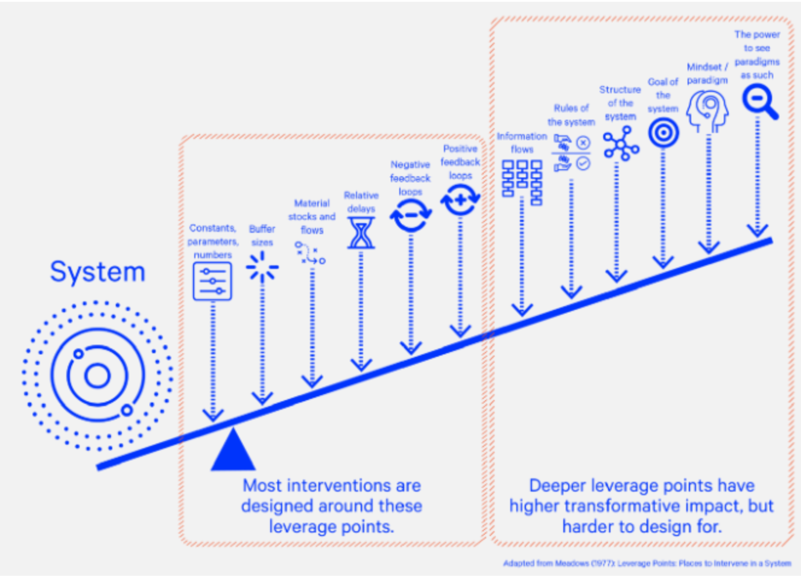

About Beyond Better and the author of this study

Beyond Better

Beyond Better is a socially invested co-operative of professionals, entrepreneurs and academics – at least 80% of fees from our commercial work is reinvested into building capacity, competence, and confidence with voluntary and third section organisations, with social enterprises and community businesses.

- For example: the fees (100%) invested in this study by the Combined Authority have allocated to: the renovation of laundry equipment and facilities at a centre providing outdoor experiences with young adults who have physical and learning disabilities; a voluntary sector group working with people who have experienced rape and sexual violence to fund an programme of accredited professional development with volunteers; and contributing to match funding for a new house unit at a shelter being built by an international charity working with the thousands of children in India who run away or are forced to leave homes because of poverty, abuse, violence and neglect.

The purpose in Beyond Better is to support and challenge teams, services, businesses and organisations in the private, public, higher education and not-for profit sectors which are keen to make sense of the difference - the social impact and value - their ways of working make with customers; and, to use such emergent awareness to effectively engage investors, commissioners and resource holders/decision makers in solution-oriented (‘We can ,,, if’) business innovation that brings competitive advantage in the business environment where they operate.

Beyond Better | Social Impact Consulting

David Hoyle.

PhD D.Litt M.Sc. M.A. (C.I.Psychol (rtd)). M.A (DipS.W/ASW.) B.Ed (Hons)

David is one of the co-founders of Beyond Better and its Chief Impact Architect. David works (and has worked) in roles across the Triple Helix of Public Service, Higher Education and Business.

In the UK Public Sector, David has practice, strategic leadership and operational management experience of single agency, multi-disciplinary and virtual teams at local, regional, and national levels in several sectors - education, social care, child and adolescent mental health and criminal justice/offender management. He has governance experience in education, health, and social care, and criminal justice. In the Higher Education field, David is a systemic thinker and radical constructivist who has successfully carried out and supervised original research and Fourth Generation evaluations into the impact of work by public sector, not-for-profits and social enterprises in the UK, USA, Europe and South Africa. In business, he has a chief executive role with a wholly family owned medium/large holding company which has a successful business portfolio spanning the property development, niche retail and hospitality sectors. In the past he worked in a senior role in the wool textile industry with a company manufacturing high quality cloth for 'Blue-Chip' customers in the fashion retail sector.

